**PROJECT : LIBRARY MANAGEMENT SYSTEM – BOOK PURCHASE UPDATE AND DELETE**

This mini project is one of the modules created for Library Management System using ABAP on SAP. This module is for purchasing , inserting ,viewing and deleting of books.

**Functionalities :**

1. Purchase of books .
2. Insertion of books into library.
3. Viewing the books present in the library.
4. Deletion of books from library.

**Assumptions:**

1 ) The admin has already logged on to the system.

2) Only admin has the right to perform purchase update and delete operations

**Tables created** : Vendor table - Z1785MINIVEN

Order table - Z1785MINIORD

Update table - ZLAB1G3UT1

Delete table – ZLAB1G3DT

Payment table - ZG31785PAYMENT

Vendor table:

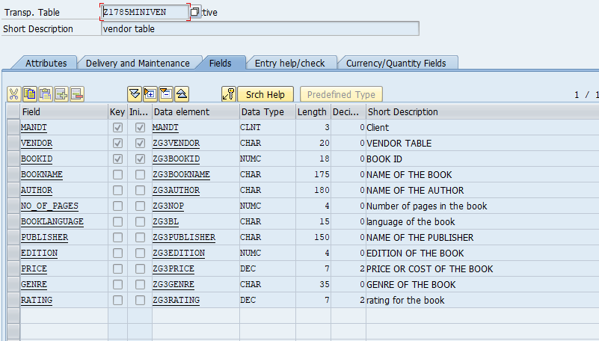

Order table

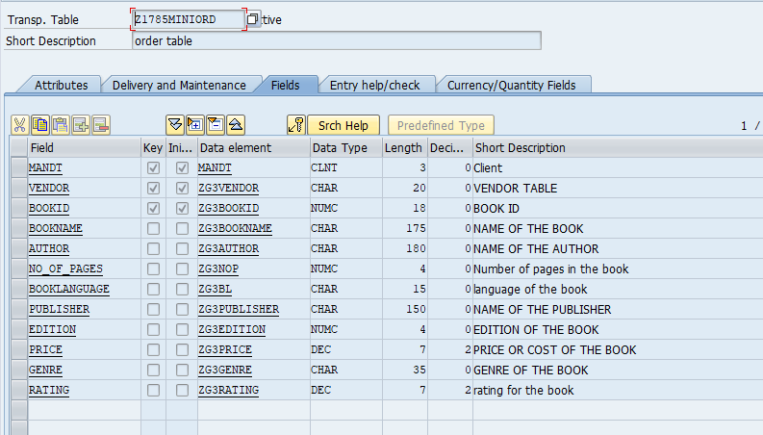

Update table

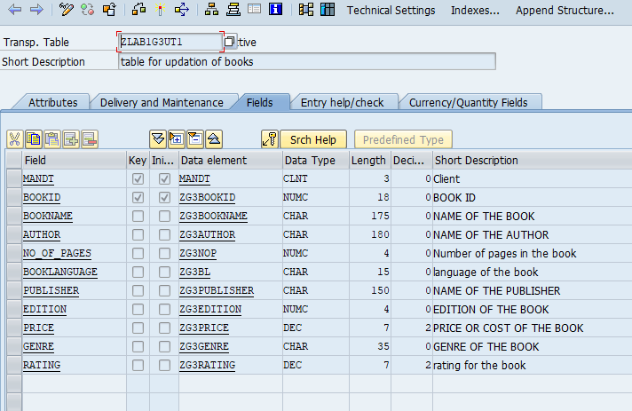

Payment table

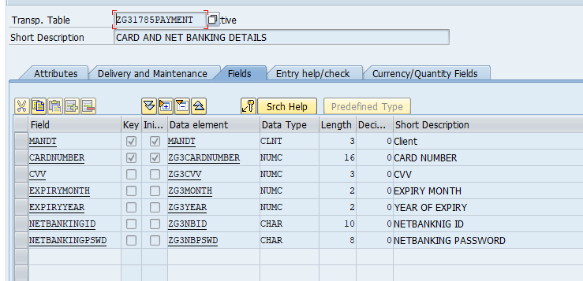

Delete table

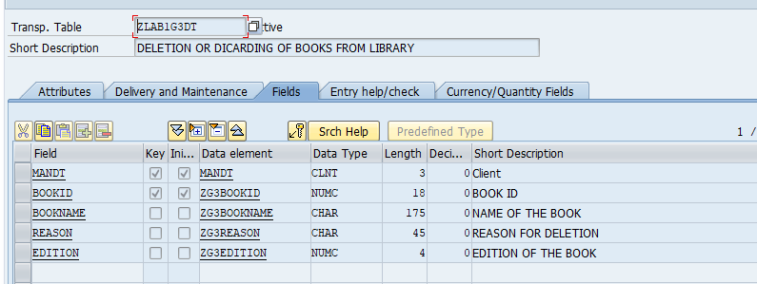

**Walk through:**

Admin screen : The admin screen shows all the functionalities that can be performed by the admin.

Screen 1

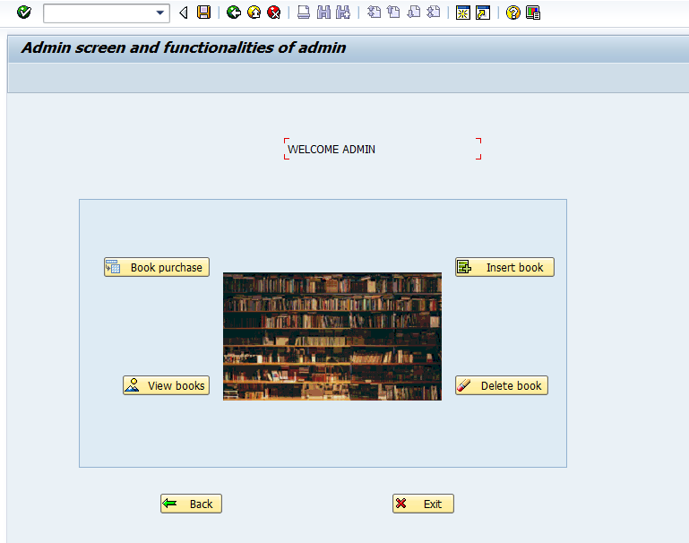

When book purchase is selected then it will navigate to screen where vendor should be selected.

When we select the vendor , then books related to that vendor will be displayed in the next screen.

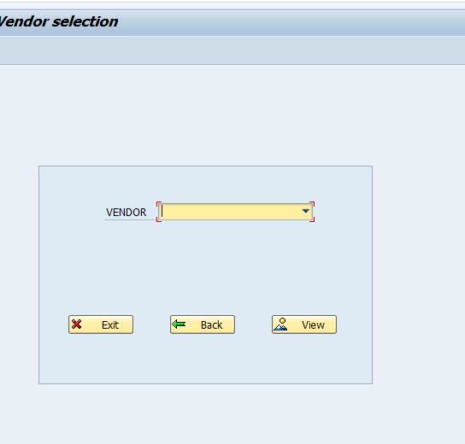

Screen 3)

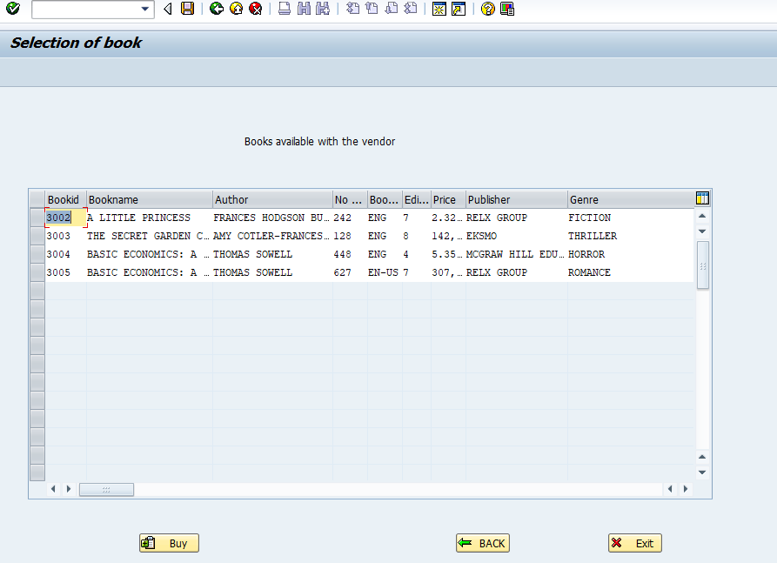

Now in this screen we need to select a book which we need and when we select buy then it will be navigated to a payment screen , where we need to pay.

Next screen is the payment screen, if we are entering the wrong credentials or not entering credentials ,then there will be a pop up showing invalid details.

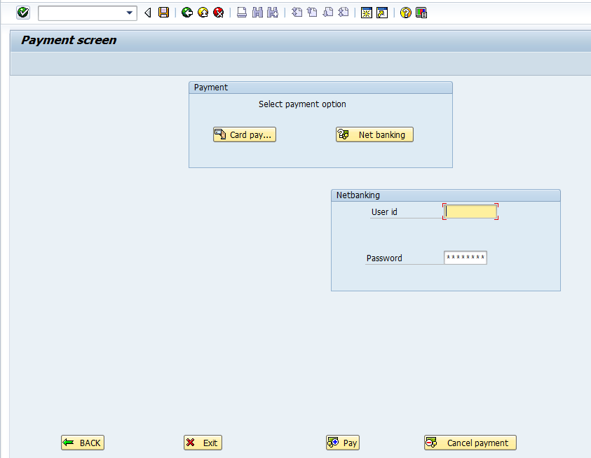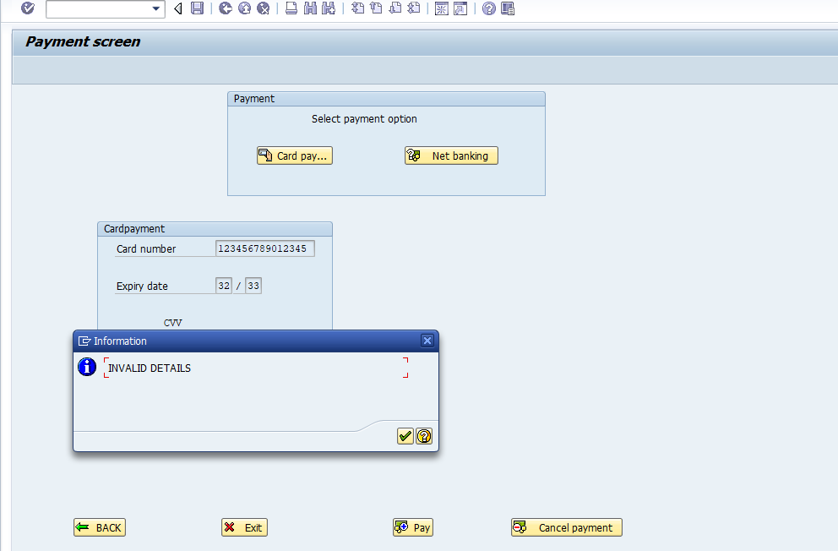

If we select net banking instead of card payment then the screen will be as follows.



When payment is done an adobe form is generated which is an invoice about the book that is bought.After that book is inserted into the update table and into the order table and deleted from vendor table.

Invoice:

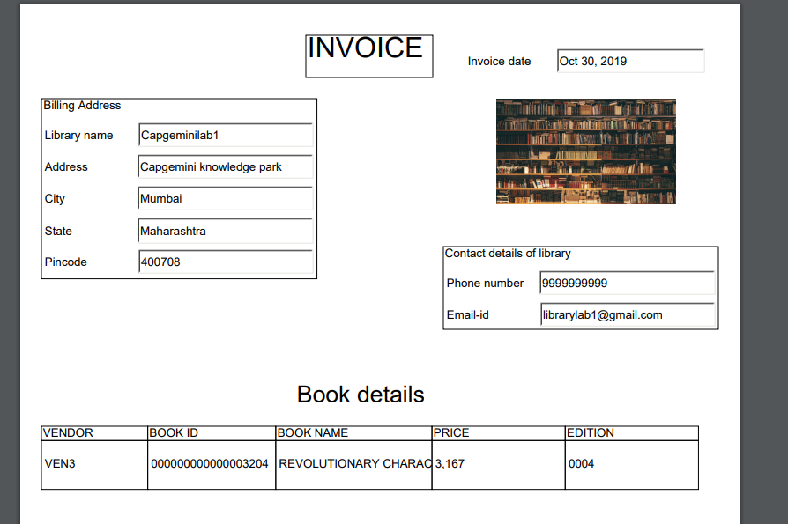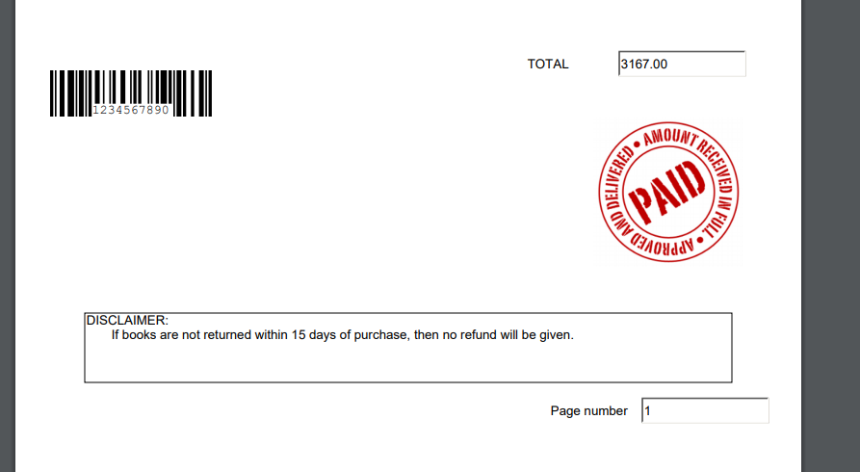

Insert books into library:

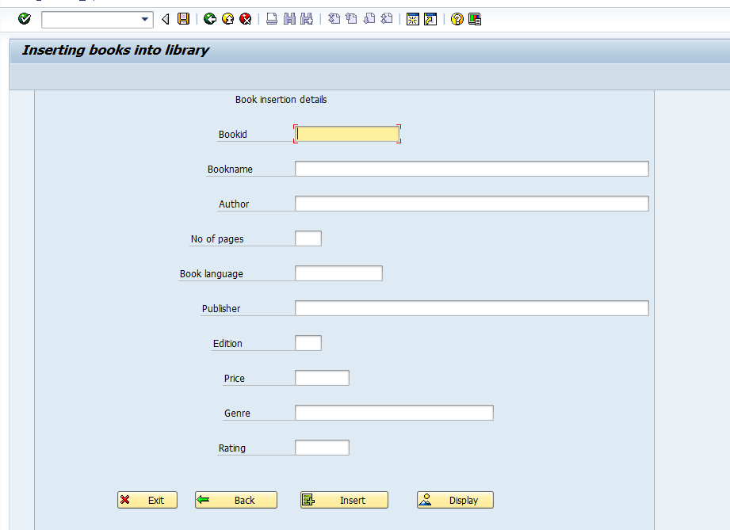

After this books is inserted into the library , we can view books by selecting display or view books push button from the main screen itself.

When we view books are displayed with the help of an interactive alv, and when we select any book we can view all the details of the book that is selected in the next screen.

Screen for books in the library.

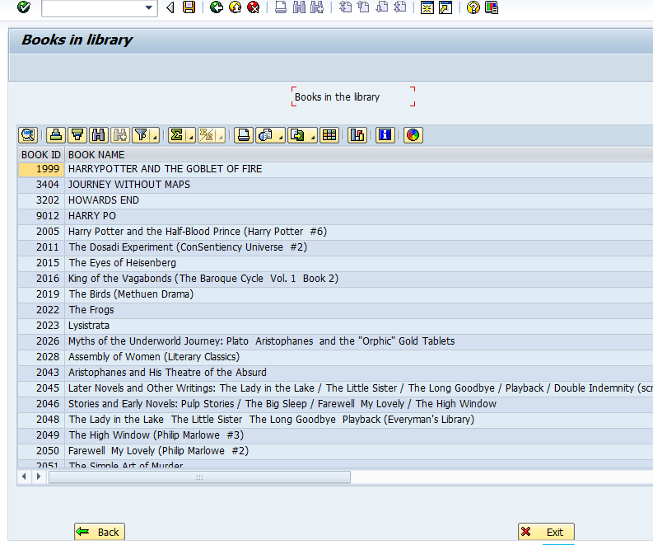

Screen for details of the selected book.

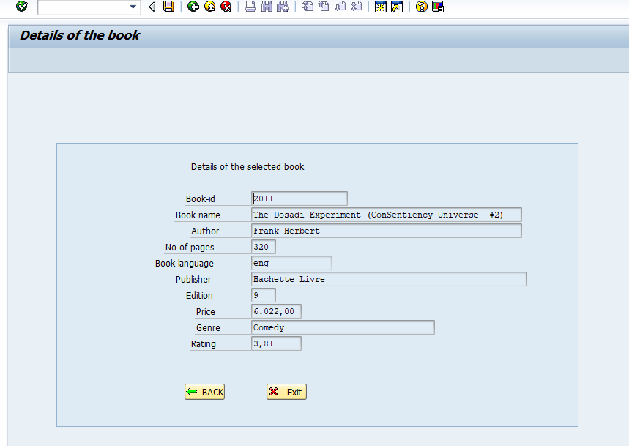

So our next motive is to delete book details . so when we select delete book we will navigate to a screen where we need to enter the bookid we want to select and with a button i.e get details we can get the details of the book that is present there. If the book with book id is not present in the library .

Screen for deleting a book:

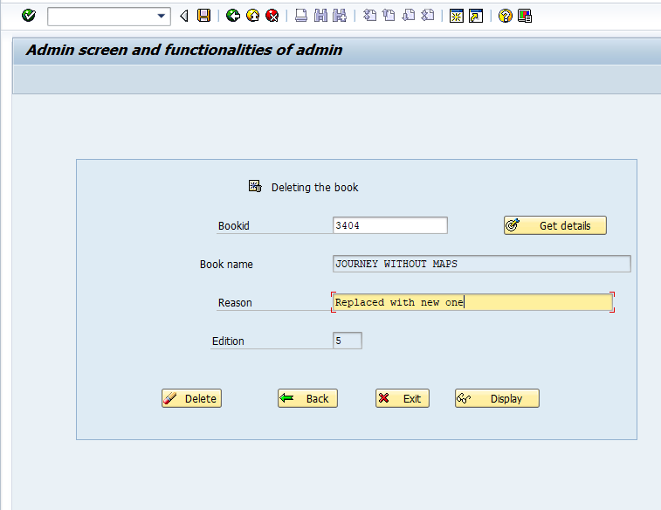

In this when we enter the book id and select get details, if book id is present then it will return the book name and edition values , if not then, a message will be popped up showing ` Enter a valid Book-id’.

If we press display then in the next screen we get all the books that are deleted in the table control with the reason also there if it is mentioned.

Screen for display of the deleted books:

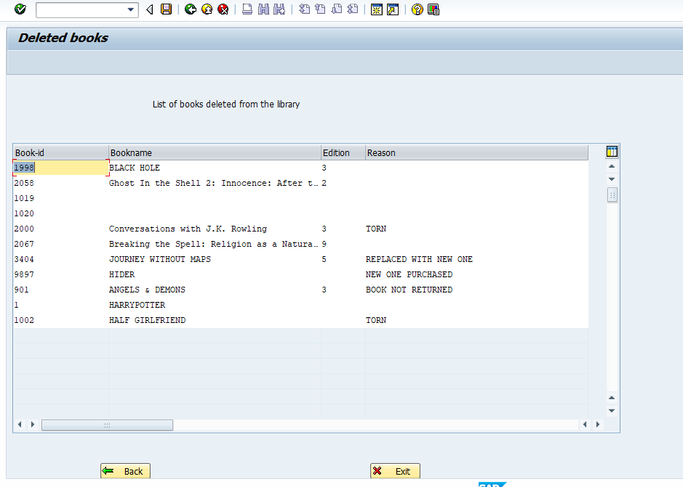

**Conclusion:**

1. We can conclude that inserting books into library directly from the vendor table has made the work a lot easier.
2. We are taking care of the books manually inserted by giving specific book-id.
3. Maintaining a record of all the deleted books will be helpful .